Anterior Cruciate Ligament Tears Explained
Authors:
Samuel Rosas, MS
Chau Nguyen, MD
Tsun yee Law, MD
Frank McCormick, MD
LESS Surgical Institute
Shoulder and Sport Division

Abstract
The purpose of this paper is to provide patients an updated, general review of anterior cruciate ligament (ACL) tears.
The internet and even the medical literature is full of ACL articles enmeshed in controversy and debate. Thus, we aim to provide a simple, concise review on the topic.
We focus on current epidemiologic data, basic anatomy and physiology, clinical presentation, physical exam findings, imaging modalities, and treatment options.

INTRODUCTION:

Anterior cruciate ligament (ACL) tears are among the most common knee injuries. An estimated 200,000 ACL tears occur each year in the United States (1), which resolves to 1 per 3500 persons (1,3) or a tear every 3 minutes. This injury commonly occurs during sporting activities such as soccer, football and other sports involving cutting movement (7)(8). Young adults are the most likely to injury the ACL. There is an increasing incidence of middle-age patients with ACL instability requiring surgery. However, the greatest risk is currently with adolescent athletes.

Anatomy and function
Proper understanding of ACL tears and associated injury patterns is guided by a general understanding of basic knee anatomy. The ACL is one of four ligaments that stabilize the knee joint, yet provides nearly 90% of knee stability (6,12). The femoral origin of ACL is on the lateral wall of the intercondylar notch. The point of insertion of ACL is on the anterior portion of the medial tibial condyle. The ACL is composed of two bundles; the anteromedial bundle, which tightens in knee flexion, and the larger posterolateral bundle, which tightens in knee extension. This difference in biomechanics allows the ACL to remain tight through a wide range of knee motion. It also enables the ACL to rotate as the knee moves from extension to flexion (6). A normal ACL stabilizes the femur on the tibia and prevents the tibia from rotating and sliding forward during agility, jumping, and deceleration followed by pivoting/sudden changes of direction (3,7-9).
Clinical presentation

ACL injuries occur more commonly in non-contact sports and typically result from landing with the knee in nearly full extension after a jump, or pivoting while changing direction after a sudden deceleration (7,8).
In addition to knee pain, swelling, and difficulty in bearing weight right after the injury, patients typically report hearing a “pop” or feeling a tearing sensation and their knee ‘giving way’ (10). Approximately 80% of patients notice a rapid onset of swelling within 3 hours of injury. However, a gradual swelling over 24 hours does not rule out an ACL tear (6,10).
Patients with chronic tears often complain of instability with side to side movements, which may cause a fall, inability to return to recreational activities and discomfort when walking or running.
Chronic tears may also lead to further development of injuries such as meniscal tears (30), and therefore may complain of meniscal pain, pain with weight bearing, kneeling and also locking sensation at the knee.

Physical Exam Findings
A focused physical examination tests include the Lachman test, the anterior drawer test, and the pivot-shift test. Assessment of ACL tear in an acute setting is best performed with the Lachman test, which has the highest sensitivity of 85% and a specificity of 94%-99% (11,13). The Lachman test evaluates the injured knee for ACL laxity by placing the knee in a position of 20 or 30 degrees flexion, and slightly externally rotated to relax the pull of the quadriceps and iliotibial band (6)(Figure 1). This positioning minimizes any secondary support given to the injured knee and allows for a better direct evaluation on ACL function. The test is positive when a non-firm endpoint is felt, and also when the tibia translates anteriorly greater than 5 mm. If in doubt, compare with the contralateral knee. The anterior drawer test has a reported sensitivity from 80% to 99% (37) and may be used in combination with the Lachman test. It consists of lying on one’s back and flexing the affected knee to 90 degrees and again pulling the tibia anteriorly to test for anterior translation (Figure 2). The pivot shift test is the most specific test for a complete ACL tear with a specificity of 98%, but with low sensitivity of 24-48% (11,13) (figure 3). The pivot-shift test is done by having the patient lay supine and applying flexion at the hip to 30 degrees, externally rotating the thigh and applying valgus and varus forces at the tibia while flexing and extending the knee. The test is positive for an ACL injury if a pop is felt while applying the valgus and varus forces at the knee, or when the patient is apprehensive with the maneuver.

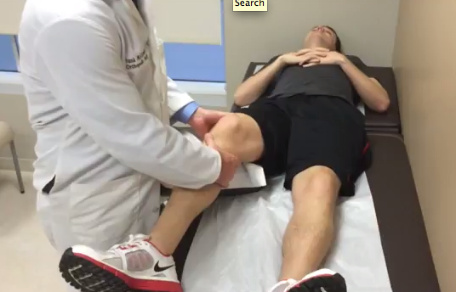

Figure 1 Lachman Test

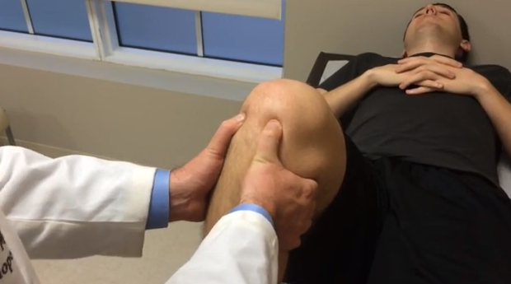
Figure 2.
Anterior Drawer Test.
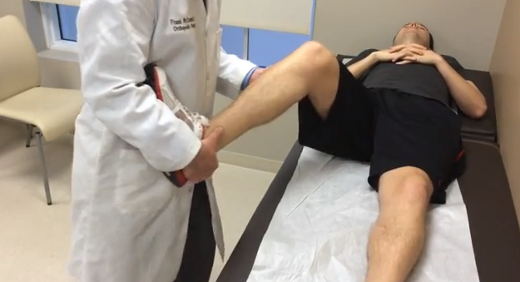
Figure 3.
Pivot shift sign
EVALUATING FOR ASSOCIATED INJURIES:
An isolated acute ACL rupture, however, occurs less than 10% of the cases (16-18); in the majority of the cases, an ACL injury occurs in conjunction with other injuries. The associated injuries include meniscus injuries, articular and subchondral bone injuries, as well as collateral ligament tears. ACL tears are mostly associated with meniscal injuries, with a high prevalence of 60 to 75% (15-18). Dr. O`Donoghue first described the “unhappy triad” in 1950 which he described as being an ACL tear, medial collateral ligament (MCL) tear and medial meniscal injury (31). Later, other authors such as Nitz and Shelbourn described the lateral meniscus as most often involved at the time of injury. These findings are currently the accepted concept of the unhappy triad, which occurs commonly to soccer players after sustaining a blow to the knee.
At the time of injury, the lateral meniscus is the one most commonly damaged but, after the injury occurs, the various forces acting at the knee cause instability and this causes the medial meniscus to damage. Chondral injuries occur at the time of injury when the hamstrings forcefully bring back the tibia into the lateral femoral condyle.

Care must be taken to evaluate the other ligaments of the knee (MCL, lateral collateral ligament, posterolateral corner injuries and posterior cruciate ligament (PCL)) since the association of these injuries is quite common. To test for MCL and LCL stability, the physician must have the patient lay down on the table and with one hand hold the femur in place and with the other apply a valgus and then a varus force at the knee in order to test for “opening” of the knee joint. When the valgus force applied creates an opening of the joint on the medial side, a MCL injury must be further inspected. By applying a varus force the LCL ligament is tested. If the opening of the joint occurs at the lateral aspect, a LCL is highly likely.
The PCL is another structure that is important to examine when an injury to the knee has occurred. Incidence of PCL injuries varies according to the patient population and the event that leads to evaluation, i.e. traumatic injury or non-traumatic. The overall incidence reported by Wind et al, is 3% in the general population, whereas in the traumatic setting is 37%. When high velocity injuries are seen, the same authors have reported a 95% of combined injuries which supports our recommendation to evaluate the PCL when knee trauma has occurred. The best clinical ways to evaluate the PCL are the posterior drawer test which is performed in the same manner as the anterior drawer test but directing the force applied at the tibia posteriorly. This test has been reported to have a 90% sensitivity and 99% specificity according to O`Keefe et al (33). A positive test constitutes an ill-defined end point of tibia translation and if the tibia translates more than 10-15mm according to some (32). The quad activation test is used in the examination of the PCL by placing the patient in a supine position and flexing the patients’ knee to 90 degrees. The examiner sits on the patients’ foot and asks the patient to “kick” or apply force directing the foot to the ceiling. This force causes the quadriceps muscle to activate and if a PCL injury exists, to translate the tibia anteriorly. This test was reviewed in a systematic review by Kopkow et al and they report sensitivity from 53% to 98% and specificity from 96 to 100% (37). The same systematic review states that the quadriceps activation test is the most useful for detecting a PCL injury.
Meniscal injuries are the most common injury associated with ACL tears.
Meniscal injuries should be examined by using the McMurray´s test and observing for joint line tenderness. The patient lay on their back on the table, then the clinician flexes the knee up to 90 degrees and applies a rotational force to the tibia. When external rotation is applied, the lateral meniscus is examined and when internal rotation is done, the medial meniscus is the one being examined. If the patient experiences pain at 90 degrees, this makes a positive McMurrays test. The sensitivity for this exam is 16-86% with a 29-96% specificity according to a Systematic review performed by Hing et al (34).According to Konan et al, who evaluated 109 patients with a history of possible meniscal injuries, the diagnostic accuracy of joint line tenderness for meniscal injuries is of 81% for medial meniscal injuries and 90% for lateral meniscus (35) (Figure 4). This test is performed by applying pressure with a finger at the joint line of the knee and the patient acknowledges whether they have pain or not.
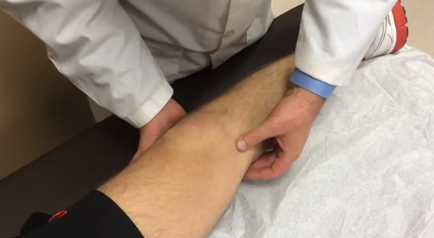
Figure 4.
Palpation for joint line tenderness
Imaging
Isolated acute ACL tear injuries typically appear normal on plain x-ray films. However, the presence of a Segond fracture, which is a small avulsion fracture of the lateral tibial eminence, is highly suggestive of ACL rupture (3), and should be followed up with MRI.
MRI is the most accurate non-invasive diagnostic modality in identifying a torn ACL, with sensitivity of 86% to 95.9%, and specificity of 91 to 95% (1). When examining an MRI for an ACL tear, the physician must search for signs of injury. There are two types of signs, direct and indirect. The direct signs are the ones that are based on the appearance of the ACL and the indirect signs are those findings seen not directly on the ACL fibers. The clear sign of an ACL injury is the presence of bone bruising at specific locations. This appears as a distortion of the normal appearance of the bone either on the femoral side or the tibia. A normal ACL appears as dark signal with a normal trajectory (>15 degrees).The lack of this dark signal implies an ACL injury. Other signs are anterior tibial translation seen in a sagittal view. This is measured by tracing a vertical line from the femur towards the ground; the posterior aspect of the tibia must not be further than 7 mm. This has a sensitivity of 86% and sensitivity of 99% for ACL tears. Also when there is less than 15% elevation from the tibial tubercle. This may indicate the ACL is intact, but stretched out and may not be functional. We suggest discussing the MRI with a radiologist or orthopedic surgeon when in doubt of any of the findings. Knowing that only 10% of ACL tears are isolated ACL injuries, the majority of patients will require an MRI because this is an important pre-operative test to plan and manage patients.
Do I need an operation for a torn ACL?
The management of ACL injuries includes both non-surgical and surgical interventions. However, the optimal treatment following a torn ACL remains controversial (1,3,12,14,19). While surgical repair is widely used in the treatment of ACL rupture in athletes, non-surgical treatment has been considered to have good outcome in the general population (5). Surgery is not always indicated in patients who suffer tears. It is indicated in high-level athletes and in people wishing to continue playing sports, especially the ones with cutting movements or people that have major instability. In all patients, we institute physical therapy after the injury in order to gain quadriceps muscle and hamstring force because these have been shown to enhance recuperation by decreasing scar tissue and contractures. This has been shown in a randomized controlled study to produce better outcomes after surgery (40).
At the urgent care center, the physician should begin with NSAIDs, ice, rest and may suggest a brace in order to decrease edema and help with stability even though this has no proven scientific data. (20)(21)

Conservative Management
Patients who choose to have a non-operative treatment are managed with consistent physiotherapy, which includes quadriceps and hamstring strengthening and stretching . Diligence in these routine strengthening exercises is required to achieve a better functional outcome. Additionally, some studies have shown the support in the use of knee bracing in chronic ACL-deficient knees, and knees post ACL reconstruction (41).. However, the role of functional knee bracing in an acute ACL tear injury remains unclear (20). There is controversy overbracings effect on improving quadriceps muscle strengthening or preventing post-traumatic osteoarthritis (20,21) (41).

Surgical Management
Reconstructive surgery of an ACL rupture involves the reconstruction of the torn ligament using a substitute graft of tendon or ligament, and passing it through drilled tunnels in the tibia and femur to approximate normal anatomy (1). ACL reconstruction is mostly performed arthroscopically. The common types of grafts used are the following: tendon autografts, tendons from the patient´s hamstring, patellar tendon and quadriceps tendon. . The hamstring tendons of the semitendinous and gracilis, of the same affected side, are frequently used and harvested (1,14,19).

Surgical Complications
Unfortunately every surgical procedure may cause complications. Complications may be subdivided in surgical and non-surgical complications. It is important to state that the complications vary depending on the type of procedure done, patient demographics, surgeon experience and other possible complications occurring due to anesthesia.
Surgical complications are the following: pain at the surgical site, infection, deep vein thrombosis, neural, vascular or ligamental injuries and others. A recent report by Hagino et al, which examined 2623 patients that underwent arthroscopic surgery reported a complication rate of 0.27% with the majority (0.11%) being intra-articular instrument breakage followed by septic arthritis in 0.08%, meniscal injury and superficial infection accounting each for 0.04%. No deep vein thrombosis or complex regional pain occurred (39).
Current debate still exists on whether ACL tears are causative of osteoarthritis development and no conclusion can be drawn at this point in time. A recent Cochrane review expands on the need for well developed randomized control trials to enlighten current scientific data on the subject.

What is the expected recovery after surgery?

Both pre-operative and post-operative rehabilitation include range of motion exercises, strengthening, and sports specific conditioning skills. While each patient has their unique recovery, most patients need a few days at home to recover from surgery, begin strengthening at 6 weeks, and return to their sport at 4 months (recreational athlete), 6 months (competitive athlete) and 9 months (professional athlete).

References

1) Spindler KP, Wright RW. Clinical Practice. Anterior Cruciate ligament tear. N Engl J Med 2008;359(20):135-42.
2) Nedeff DD, Bach BR Jr. Arthroscopic anterior cruciate ligament reconstruction using patellar tendon autografts: a comprehensive review of contemporary literature. Am J Knee Surg. 2001;14:243-258.
3) Morelli V, Bright C, Fields A. Ligamentous injuries of the knee: anterior cruciate, medial collateral, posterior cruciate, and posterolateral corner injuries. Prim Care 2013;40(2):335-56.
4) Musculoskeletal problems are common in family practice [Conference Highlights] Am Fam Physician. 1996;54(8):2524.
5) Casteleyn P-P, Handelberg F. Non-operative management of anterior cruciate ligament injuries in the general population. Journal of Bone and Joint Surgery – British Volume 1996;78:446-51.
6) Bach BR Jr, Alford JW. Managing ACL tears: Evaluation and diagnosis.
J Musculoskel Med. 2004;21:381G-390.

7) Hewett TE, Myer GD, Ford KR. Anterior cruciate ligament injuries in female athletes: part 1, mechanisms and risk factors. Am J Sports Med 2006;34(2):299- 311
8) Shimokochi Y, Shultz SJ. Mechanisms of noncontact anterior cruciate ligament injury. J Athl Train 2008;43(4):396-408.
9) Acevedo RJ, Rivera-vega A, Miranda G, Micheo W. Anterior cruciate ligament injury: identification of risk factors and prevention strategies. Curr Sports Med Rep. 2014;13(3):186-91.
10) Carborn DN, Johnson BM. The natural history of the anterior cruciate ligament- deficient knee. Clin Sports Med 1993;12(4):625-35.
11) Benjaminse A, Gokeler A, van der Schans CP. Clinical diagnosis of an anterior cruciate ligament rupture: a meta-analysis. J Ortho Sports Phys Ther 2006;36:267.
12) Linko E, Harilainen A, Malmivaara A, et al. Surgical versus conservative interventions for anterior cruciate ligament ruptures in adults. Cochrane Database Syst Rev 2005;(2):CD001356.
13) Solomon DH, Simel DL, Bates DW, et al. The rational clinical examination. Does this patient have a torn meniscus or ligament of the knee? Value of the physical examination. JAMA 2001;286(13):1610-20.
14) Sarraf KM, Sadri A, Thevendran G, et al. Approaching the ruptured anterior cruciate ligament. Emerg Med J 2011;28:644-9.
15) Piasecki DP, Spindler KP, Warren TA, Andrish JT, Parker RD. Intraarticular injuries associated with anterior cruciate ligament tear: findings at ligament reconstruction in high school and recreational athletes: an analysis of sex-based differences. Am J Sports Med 2003;31:601-5.
16) Bowers, AL, Spindler, KP, McCarty, EC, Arrigain, S. Height, weight, and BMI predict intra-articular injuries observed during ACL reconstruction: evaluation of 456 cases from a prospective ACL database. Clin J of Sport Med 2005;15(2):9-13.
17) Hernandez, L, Micheo, W, Amy, E. Rehabilitation update for the anterior cruciate ligament injured patient: Current concepts. Boletin de la Asociacion Medica de Puerto Rico 2006;98(1):62-72.
18) Miyasaka, KC, Daniel, DM, Stone, ML, Hirschman, P. The incidence of knee ligament injuries in the general population. Am J Knee Surg 1991;4:43-8.
19) Monk AP, Hopewell S, Harris K, Davies LJ, Beard D, Price A. Surgical versus conservative interventions for treating anterior cruciate ligament injuries. Cochrane Database Syst Rev 2014;(6):CD011166.
20) Swirtum LR, Jansson A, Renstrom P. The effects of a functional knee brace during early treatment of patients with a non-operated acute anterior cruciate ligament tear: a prospective randomized study. Clin J Sport Med 2005;15:299-304.
21) Sherman MF, Warren RF, Marshall JL, et al. A clinical and radiological analysis of 127 anterior cruciate insufficient knees. Clin Orthop 1988;227:229-37.
22) Seng K, Appleby D, Lubowitz JH. Operative versus non-operative treatment of anterior cruciate ligament rupture in patients aged 40 years or older: an expected- value decision analysis. Arthroscopy 2008;24:914-20.
23) Frobell, RB, Roos, EM, Roos, HP, Ranstam, J, Lohmander, LS. A randomized trial of treatment for acute anterior cruciate ligament tears. New England Journal of Medicine 2010;363:331-42.
24) Lohmander S, Englund PM, Dahl LL, Roos EW. The long-term consequence of anterior cruciate ligament and meniscus injuries. Am J Sports Med 2007;35(10):1756-69.
25) Rout R, McDonnell S, Hulley P, Jayadev C, Khan T, Carr A, et al. The pattern of cartilage damage in antero-medial osteoarthritis of the knee and its relationship to the anterior cruciate ligament. J Orthop Res 2013;31(6):908-13.
26) Small NC, Glogau AI, Berezin MA, Farless BL. Office operative arthroscopy of the knee: technical considerations and a preliminary analysis of the first 100 patients. Arthroscopy: The Journal of Arthroscopic and Related Surgery. 1994;10(5):534-9.
27) Halbrecht JL, Jackson DW. Office arthroscopy: A diagnostic alternative. Arthroscopy: The Journal of Arthroscopic and Related Surgery. 1992; 8(3):320-326
28) Wong E, Stewart M. Predicting the scope of practice of family physicians. Can Fam Physician. 2010;56(6):e219-25.

29) Von porat A, Roos EM, Roos H. High prevalence of osteoarthritis 14 years after an anterior cruciate ligament tear in male soccer players: a study of radiographic and patient relevant outcomes. Ann Rheum Dis. 2004;63(3):269-73.

30) Yoo JC, Ahn JH, Lee SH, Yoon YC. Increasing incidence of medial meniscal tears in nonoperatively treated anterior cruciate ligament insufficiency patients documented by serial magnetic resonance imaging studies. Am J Sports Med. 2009;37(8):1478-83.

31) Barber F. Allen. What is the terrible triad?. Arthroscopy: The Journal of Arthroscopy and related surgery. 1992: Volume 8 (1): 19-22.

32) Wind WM, Bergfeld JA, Parker RD. Evaluation and treatment of posterior cruciate ligament injuries: revisited. Am J Sports Med. 2004;32(7):1765-75.

33) O'Keefe KP, Sanson TG. Chapter 278. Hip and Knee Pain. In: Tintinalli JE, Stapczynski J, Ma O, Cline DM, Cydulka RK, Meckler GD, T. eds. Tintinalli's Emergency Medicine: A Comprehensive Study Guide, 7e. New York, NY: McGraw-Hill; 2011.

34) Hing W, White S, Reid D, Marshall R. Validity of the McMurray's Test and Modified Versions of the Test: A Systematic Literature Review. J Man Manip Ther. 2009;17(1):22-35.

35) Konan S, Rayan F, Haddad FS. Do physical diagnostic tests accurately detect meniscal tears?. Knee Surg Sports Traumatol Arthrosc. 2009;17(7):806-11.

36) Malanga GA, Andrus S, Nadler SF, Mclean J. Physical examination of the knee: a review of the original test description and scientific validity of common orthopedic tests. Arch Phys Med Rehabil. 2003;84(4):592-603.

37) Kopkow C, Freiberg A, Kirschner S, Seidler A, Schmitt J. Physical examination tests for the diagnosis of posterior cruciate ligament rupture: a systematic review. J Orthop Sports Phys Ther. 2013;43(11):804-13.

38) Ng WH, Griffith JF, Hung EH, Paunipagar B, Law BK, Yung PS. Imaging of the anterior cruciate ligament. World J Orthop. 2011;2(8):75-84.

39) Hagino T, Ochiai S, Watanabe Y, et al. Complications after arthroscopic knee surgery. Arch Orthop Trauma Surg. 2014;

40) Shaarani SR, O'hare C, Quinn A, Moyna N, Moran R, O'byrne JM. Effect of prehabilitation on the outcome of anterior cruciate ligament reconstruction. Am J Sports Med. 2013;41(9):2117-27.

41) Théoret D, Lamontagne M. Study on three-dimensional kinematics and electromyography of ACL deficient knee participants wearing a functional knee brace during running. Knee Surg Sports Traumatol Arthrosc. 2006;14(6):555-63.

